Project Report

on

**Building Plan Management System**

Developed For

**Maharashtra Government**

Submitted to

**University of Mumbai**

In fulfillment of requirement of

**Master of Computer Application**

Submitted by

**Shreya Mehta**

**Roll No: 49**

Under the Guidance of

**MRS. JAYAMALA KANAGALA**

**Project Manager, S2 infotech international limited**

**Prof. Sonu Gupta**

**Asst. Professor, TIMSCDR**

**Thakur Institute of Management Studies, Career Development & Research**

**Mumbai**

**2020-2021**

# Certificate

This is to certify that the project entitled **Building Plan Management System** submitted by **Shreya Mehta**, for fulfillment for the degree of Master of Computer Applications from University of Mumbai.

It is the original software developed by her and has undergone the requisite duration as prescribed by the **University of Mumbai** for Project Work.

**Internal Guide: Director:**

**External Examiner**

**ACKNOWLEGEMENT**

The internship opportunity I had with **S2 Infotech International Limited** was a great chance for learning and professional development. Therefore, I consider myself as a very lucky individual as I was provided with an opportunity to be a part of it. I am also grateful for having a chance to meet so many wonderful people and professionals who led me though this internship period.

Bearing in mind previous I am using this opportunity to express my deepest gratitude and special thanks to the **CHIEF MANAGER** of **S2 Infotech International Limited** who in spite of being extraordinarily busy with her duties, took time out to hear, guide and keep me on the correct path and allowing me to carry out my project at their esteemed organization and extending during the training.

I express my deepest thanks to **MRS. JAYAMALA KANAGALA**for taking part in useful decision & giving necessary advices and guidance and arranged all facilities to make life easier. I choose this moment to acknowledge his contribution gratefully.

I would also like to thank **DR. VINITA GAIKWAD, DIRECTOR** and my guide **PROF. SONU GUPTA** for their constant support during my internship.

The main motivation and support were from **MY PARENTS** and **MY FRIENDS** who not only allowed me to work but constantly made sure I do good and that I am not pressurized with anything.

I perceive as this opportunity as a big milestone in my career development. I will strive to use gained skills and knowledge in the best possible way, and I will continue to work on their improvement, in order to attain desired career objectives. Hope to continue co-operation with all of you in the future.

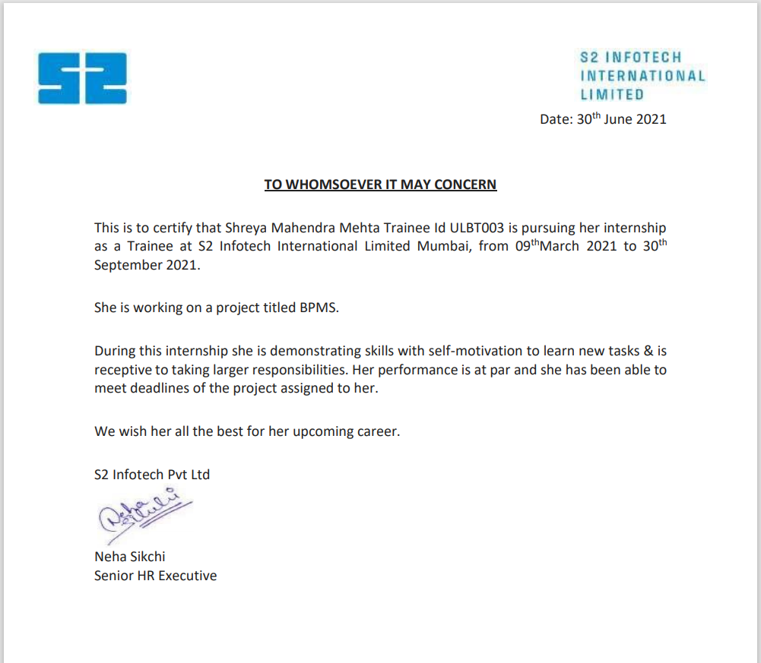

**INDEX**

|  |  |  |
| --- | --- | --- |
| **Sr. No.** | **Title** | **Page No.** |
| **1** | **Introduction** | 1-2 |
| 1.1 About the Organization |
| 1.2 Problem Definition |
| 1.3 Objective & Scope |
| 1.4 System Requirements |
| **2** | **Literature Survey** | 3-4 |
| 2.1 Introduction |
| 2.2 About the Domain |
| 2.3 Existing System |
| 2.4 Disadvantages of Existing System |
| 2.5 Proposed System |
| **3** | **Analysis** | 5-12 |
| 3.1 Introduction |
| 3.2 Software Requirement Specifications |
| 3.2.1 User Requirement |
| 3.2.2 Software Requirement |
| 3.2.3 Hardware Requirement |
| 3.3 Flow Chart |
| 4 | **Design** | 13-14 |
| 4.1 Introduction |
| 4.2 Use Case Diagram |
| **5** | **Implementation & Result** | 15-19 |
| 5.1 Introduction |
| 5.2 Output Screens |
| 5.3 Result Analysis |
| **6** | **Testing and Validation** | 20-22 |
| 6.1 Introduction |
| 6.2 Test Cases and Result |
| **7** | **Future Enhancements** | 23 |
| **8** | **Limitations** | 24 |
| **9** | **Conclusion** | 25 |
| **10** | **References** | 26 |

**INTRODUCTION**

* 1. **ABOUT ORGANIZATION**

S2IIL has earned the trust and respect of its clients with a series of business successes. Commencing 2005, it has steadily expanded its offerings across multiple industries and verticals. Today, servicing a variety of customers in multiple locations, has generated value for all its stakeholders. Strong leadership and investment in infrastructure has given confidence to its customers which significantly has contributed to the company’s rapid growth. S2IIL constantly invests in state-of-the-art infrastructure, building people competence, adopting quality processes (CMMI, PCMMI and ISO9001/27001 certifications) and leading-edge technologies to add business value for all its clients. It enjoys a strategic partnership and preferred vendor status with all its customers in manpower solutions (recruitment, staffing, etc.), healthcare and IT/ITES solutions.

**1.2. PROBLEM DEFINITION**

There are configurations required in Building Plan Management System as per UDCPR provided by Maharashtra Government. As an ambitious project under the Ease of Doing Business initiative of Central Government, Hon. Chief Minister has agreed and urban Development Department has decided, of creating a portal and implementing Building Plan Management System (BPMS) with a vision of standardizing various building permission processes at Municipal Councils across Maharashtra.

Maharashtra Information Technology Corporation (MIT) with Department of Information Technology (DIT, Maharashtra) has decided to make this system available through proper evaluation process. Project covers all the councils across Maharashtra for automation and implementation of Building permissions and all workflow-based systems used in the councils for different types of permissions like Building Permission. Tree Felling, Plinth, occupancy etc. Solution has an innovative touch with the 3D models being prepared for the plans submitted and mobile based BPMS Connect application for inspections and real time updates to stake holders.

**1.3. OBJECTIVE AND SCOPE**

S2 Infotech International Limited is implementing online module for different Building Permission like Part Occupancy, Revised Building Permission etc.

This project will help to get helps all the applicants and technical person to register got building/Plot required and go through a smooth process online.

**1.4. SYSTEM REQUIREMENSTS**

* Access Everywhere

The software provide all the solutions instead of going to government office the total process is done online from registration to approval of the document.

**LITERATURE SURVEY**

**2.1. INTRODUCTION**

Built on a single code, it fundamentally alters what the Technical Person and architect can achieve.[5]

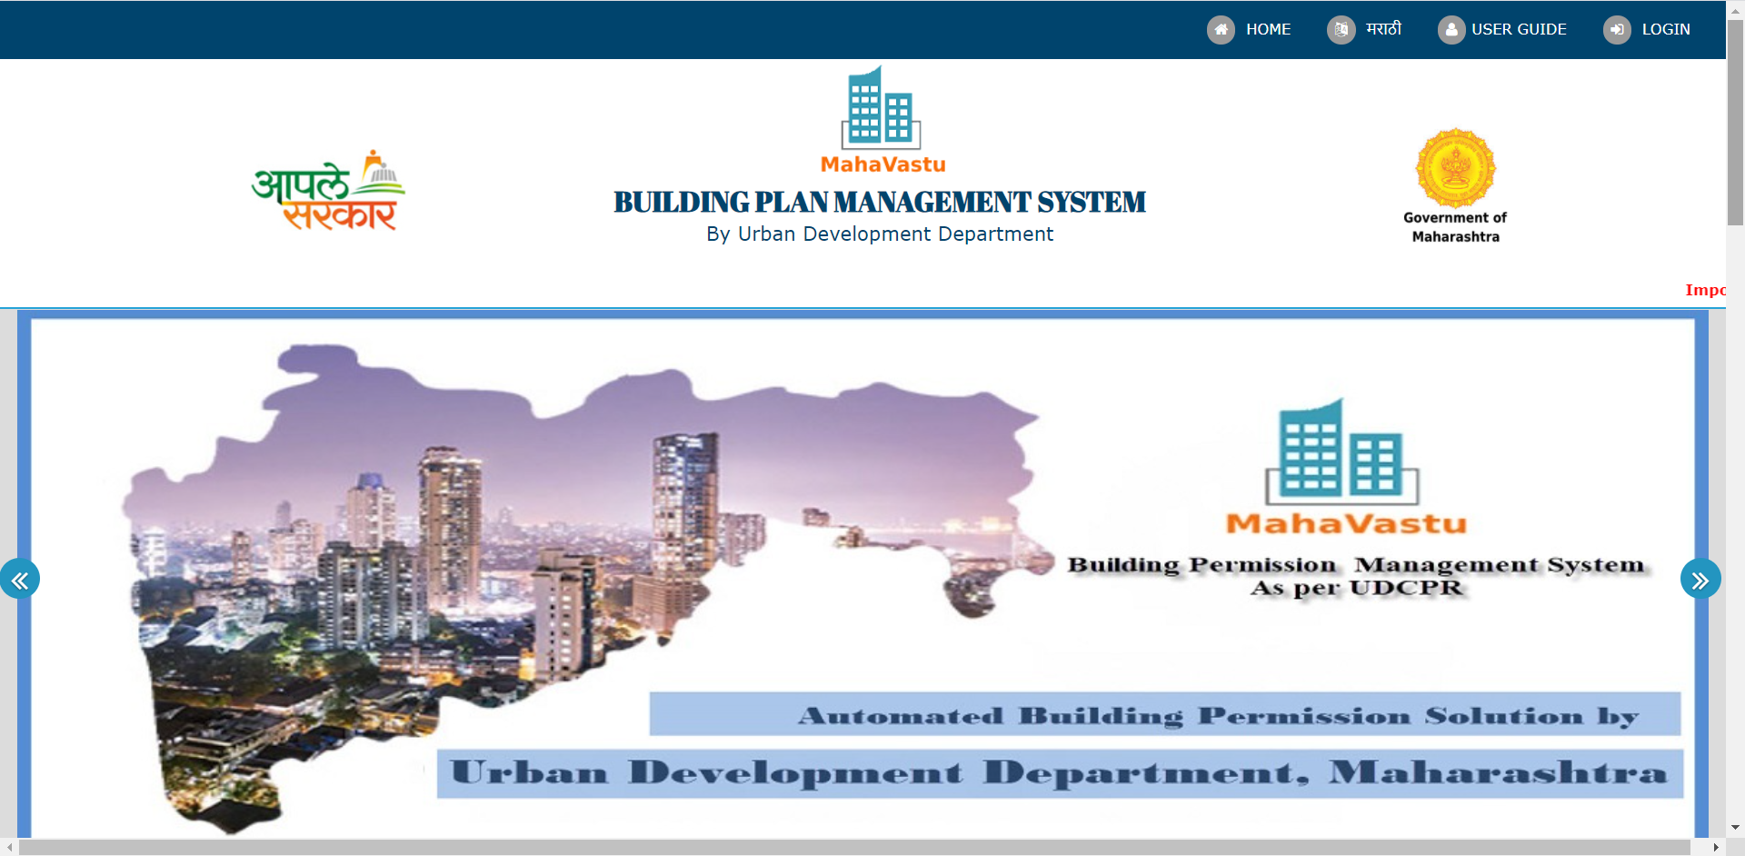

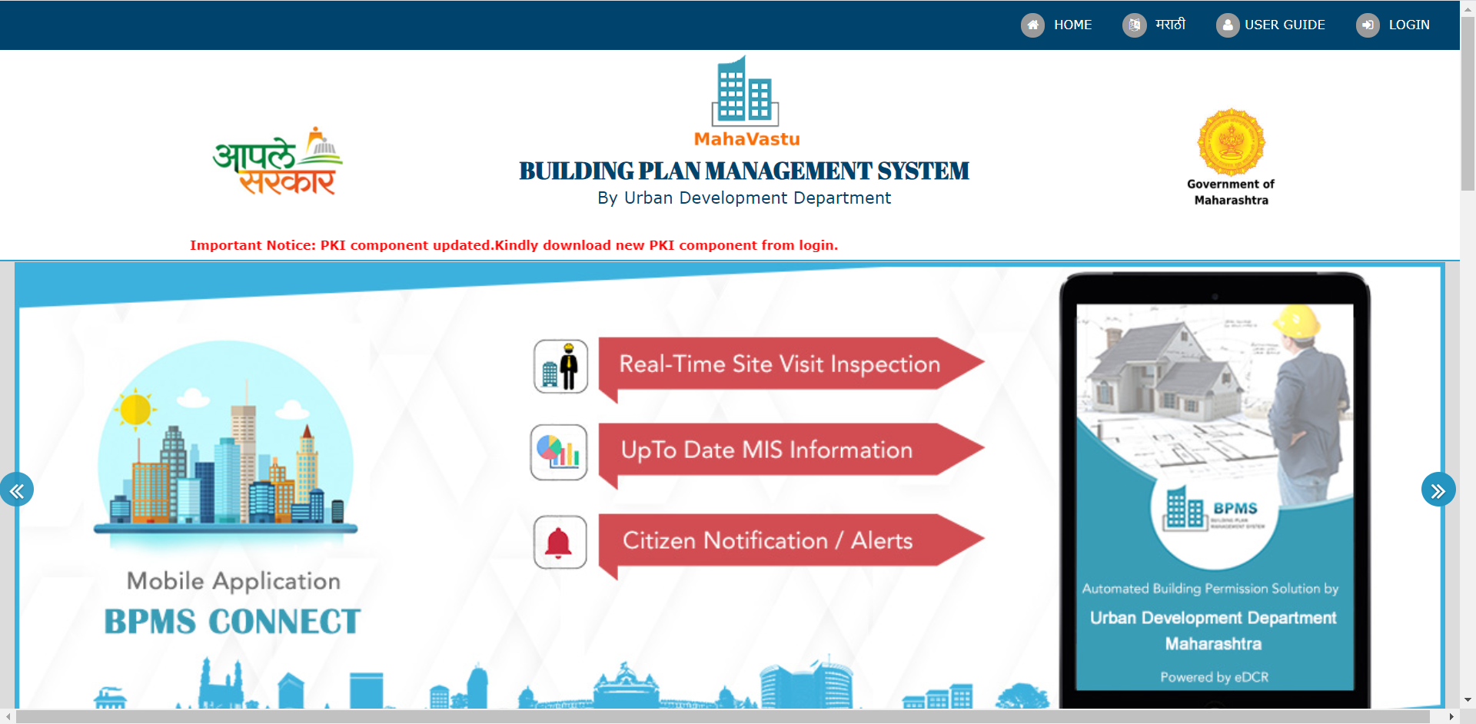Fig. Building Plan Management System [5]

Best-in-class is not one-size-fits all. Easy configuration is a core principle of the BPMS System. Meet your users’ needs, from custom UI and workflows to new forms and fields. Check your respective details about the building permission using the ticket id generated. [5]

**2.2. EXISTING SYSTEM**

**TP-Client Software**

Previously there were two applications for registering and Uploading TP-Client drawings. So now it’s the part of online system itself. The user does not need to shift to the other application.

**2.3. DISADVANTAGE OF EXISTING SYSTEM**

**TP Client Software**

* Lack of controls, vulnerable to fraud.
* No log of change.
* Not prepared for disaster.
* Susceptible to costly human errors.
* Difficult to troubleshoot or test.
* Regulatory compliance challenges

**2.4. PROPOSED SYSTEM**

**BUILDING PLAN MANAGEMENT SYSTEM**

This project involves pre-sourcing data preparation, sourcing, integration with analysis & reporting for different processes to be implemented.

There are configurations required in BPMS system to show the information in tabular format (like Proposal code generated as per the registration done, EKYC is required) which is required for Owner and Technical Person. After applying for proposal respective admin or head can view the proposal and tale further actions.

The project also involves Ticket System where any person can log the ticket about the issue faced by them while using the software to maintain master data required for analysis and reporting. Analysis reports will be developed on the software itself by doing this we can reach to customer satisfaction and it’s easy for the project leads to maintain the issues using this and resolve it at the earliest.

**ANALYSIS**

**3.1. INTRODUCTION**

An analysis is a systematic examination and evaluation of data or information, by breaking it into its component parts to uncover their interrelationships. There are various types of analysis which we had to go through i.e. Requirement Analysis, Competitive Analysis, Program Analysis, Object-oriented analysis, and design.

Requirement analysis is the most important and fundamental stage in SDLC. It is performed by the senior members of the team with inputs from the customer, the sales department, market surveys and domain experts in the industry. This information is then used to plan the basic project approach and to conduct product feasibility study in the economical, operational and technical areas.

Planning for the quality assurance requirements and identification of the risks associated with the project is also done in the planning stage. The outcome of the technical feasibility study is to define the various technical approaches that can be followed to implement the project successfully with minimum risks.

Fig. Analysis

* **Feasibility Study**

To evaluate the feasibility, a feasibility study is performed, which determines whether the solution considered to accomplish the requirements is practical and workable in the software. Information such as resource availability, cost estimation for software development, benefits of the software to the organization after it is developed and cost to be incurred on its maintenance are considered during the feasibility study. The objective of the feasibility study is to establish the reasons for developing the software that is acceptable to users, adaptable to change and conformable to established standards.

The different types of Feasibility study

* Technical feasibility
* Schedule feasibility
* Operational feasibility
* Economic feasibility

**A. Technical Feasibility**

Since technical feasibility deals with the required software and hardware resource for the ongoing project, after the detailed study done for the project, we found that the project will meet its standard performance. On a PHP based server platform along with AUTO CAD for drawing and SQL backend support. This software runs smooth on an AUTO CAD software.

**B. Schedule Feasibility**

In order to complete the project on time, the project has been divided into multiple modules based on their complexity, graphic, and backend functionality. Each module is developed sequentially and is interlinked.

**C. Economic Feasibility**

Since this project is live base, it requires a TP Client Software serverless server with Sql supported and .Net framework

Thus, the total cost of the system will include the development cost and the above-mentioned requirement cost for the system.

**D. Operational Feasibility**

Proposed Portfolio Website is beneficial only if it can be turned into information systems that will meet the organizations operating requirements.

* The System has user friendly and interactive Design for attracting the users
* Users do not have to worry about the accuracy of Data as the whole system will be thoroughly examined and tested before pushing to production.

**3.2. SOFTWARE REQUIREMENT SPECIFICATIONS**

A software requirements specification (SRS) is a detailed description of a software system to be developed with its functional and non-functional requirements. The SRS is developed based the agreement between customer and contractors. It may include the use cases of how user is going to interact with software system. The software requirement specification document consistent of all necessary requirements required for project development. To develop the software system, we should have clear understanding of Software system. To achieve this, we need to continuous communication with customers to gather all requirements.

A good SRS defines the how Software System will interact with all internal modules, hardware, communication with other programs and human user interactions with wide range of real-life scenarios. Using the Software requirements specification (SRS) document on QA lead, managers creates test plan. It is very important that testers must be cleared with every detail specified in this document in order to avoid faults in test cases and its expected results.

It is highly recommended to review or test SRS documents before start writing test cases and making any plan for testing. Let’s see how to test SRS and the important point to keep in mind while testing it.

Software Requirement Specification (SRS)

1. Correctness of SRS should be checked. Since the whole testing phase is dependent on SRS, it is very important to check its correctness. There are some standards with which we can compare and verify.

2. Ambiguity should be avoided. Sometimes in SRS, some words have more than one meaning and this might confuse testers making it difficult to get the exact reference. It is advisable to check for such ambiguous words and make the meaning clear for better understanding.

3. Requirements should be complete. When tester writes test cases, what exactly is required from the application, is the first thing which needs to be clear. For e.g. if application needs to send the specific data of some specific size then it should be clearly mentioned in SRS that how much data and what is the size limit to send.

4. Consistent requirements. The SRS should be consistent within itself and consistent to its reference documents. If you call an input “Start and Stop” in one place, don’t call it “Start/Stop” in another. This sets the standard and should be followed throughout the testing phase.

5. Verification of expected result: SRS should not have statements like “Work as expected”, it should be clearly stated that what is expected since different testers would have different thinking aspects and may draw different results from this statement.

6. Testing environment: some applications need specific conditions to test and also a particular environment for accurate result. SRS should have clear documentation on what type of environment is needed to set up.

7. Pre-conditions defined clearly: one of the most important part of test cases is pre-conditions. If they are not met properly then actual result will always be different expected result. Verify that in SRS, all the pre-conditions are mentioned clearly.

8. Requirements ID: these are the base of test case template. Based on requirement Ids, test case ids are written. Also, requirements ids make it easy to categorize modules so just by looking at them, tester will know which module to refer. SRS must have them such as id defines a particular module.

9. Security and Performance criteria: security is priority when a software is tested especially when it is built in such a way that it contains some crucial information when leaked can cause harm to business. Tester should check that all the security related requirements are properly defined and are clear to him. Also, when we talk about performance of a software, it plays a very important role in business so all the requirements related to performance must be clear to the tester and he must also know when and how much stress or load testing should be done to test the performance.

10. Assumption should be avoided: sometimes when requirement is not cleared to tester, he tends to make some assumptions related to it, which is not a right way to do testing as assumptions could go wrong and hence, test results may vary. It is better to avoid assumptions and ask clients about all the “missing requirements” to have a better understanding of expected results.

11. Deletion of irrelevant requirements: there are more than one team who work on SRS so it might be possible that some irrelevant requirements are included in SRS. Based on the understanding of the software, tester can find out which are these requirements and remove them to avoid confusions and reduce work load.

12. Freeze requirements: when an ambiguous or incomplete requirement is sent to client to analyze and tester gets a reply, that requirement result will be updated in the next SRS version and client will freeze that requirement. Freezing here means that result will not change again until and unless some major addition or modification is introduced in the software.

**3.2.1. User Requirement**

* The project involves:
  + Pre-sourcing data preparation,
  + Sourcing,
  + Analysis & Reporting and
  + TP-Client Software & SQL
  + for different processes to be implemented.
* Sourcing involves:
* Analytic Reports

**3.2.2. Software Requirement**

* Operating System – Any Operating System with browser supported.
* Hard Disk – 2 GB

**3.2.3. Hardware Requirement**

* Working System (PC/Laptop/Smartphones)
* Proper Internet/WiFi Connection
* Keyboard
* Mouse
* Minimum 2GB RAM.

**3.3. FLOW CHART**

|  |
| --- |
| Requirement Analysis |

|  |
| --- |
| Register on the BPMS Portal |

|  |
| --- |
| Login on the Portal |

|  |
| --- |
| Apply for the Permission |

|  |
| --- |
| EKYC is compulsory |

|  |
| --- |
| Proposal sent to Authority for approval |

|  |
| --- |
| User Training |

Fig. Flow Chart of Applicant for the Proposal

**DESIGN**

**4.1. INTRODUCTION**

System design is the process of defining the elements of a system such as the architecture, modules and components, the different interfaces of those components and the data that goes through that system. It is meant to satisfy specific needs and requirements of a business or organization through the engineering of a coherent and well-running system.

* **System design phase consists of the following processes:**

● **Prepare for System Design**, where the existing project repositories are expanded to accommodate the design work products, the technical environment and tools needed to support system design is established, and training needs of the team members involved in system design are addressed.

● **Define Technical Architecture**, where the foundation and structure of the system are identified in terms of system hardware, system software, and supporting tools, and the strategy is developed for distribution of the various system components across the architecture.

● **Define System Standards**, where common processes, techniques, tools, and conventions that will be used throughout the project are identified in an attempt to maximize efficiencies and introduce uniformity throughout the system.

● **Create Physical Database**, where the actual database to be used by the system is defined, validated, and optimized to ensure the completeness, accuracy, and reliability of the data.

● **Prototype System Components**, where various components of the solution may be developed or demonstrated in an attempt to validate preliminary functionality, to better illustrate and confirm the proposed solution.

● **Produce Technical Specifications**, where the operational requirements of the system are translated into a series of technical design specifications for all components of the system, setting the stage for System Construction.

**Use Case Diagram**

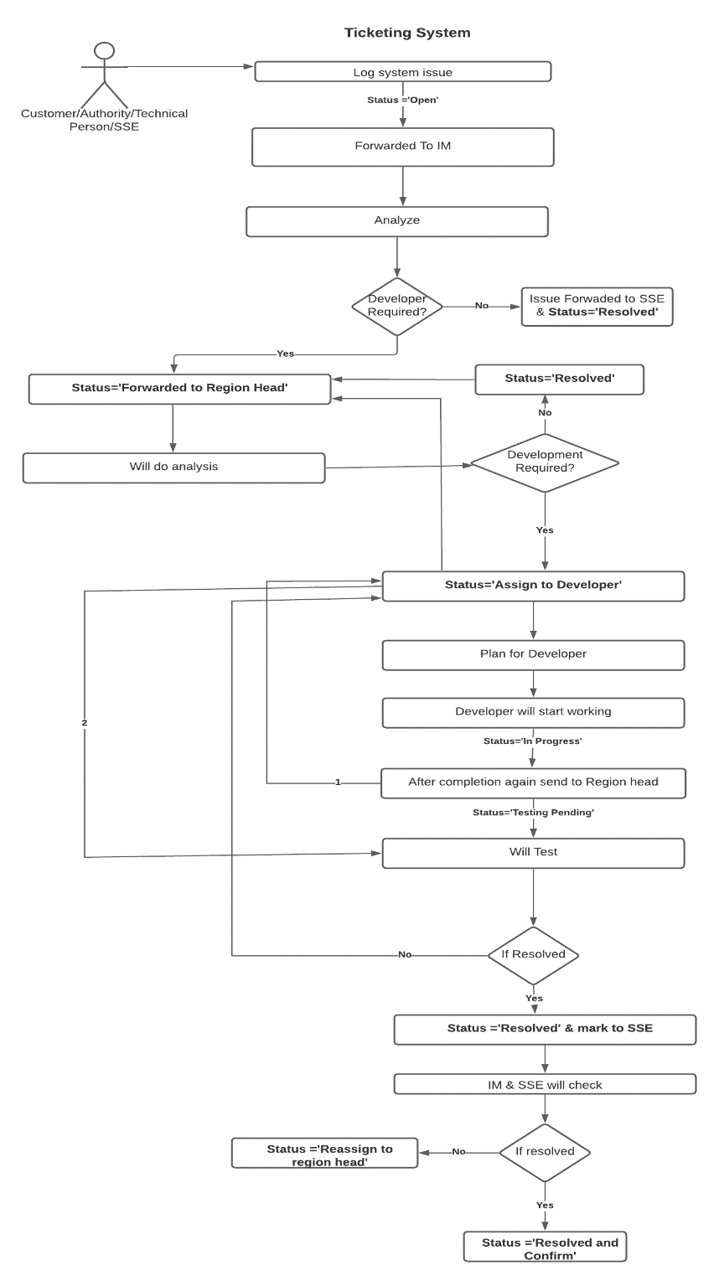

Fig.Ticket System Usecase Diagram

**IMPLEMENTATION AND RESULTS**

**5.1. INTRODUCTION**

* The project involves:
  + - Pre-sourcing data preparation,
    - Sourcing,
    - Analysis & Reporting and
    - Integration with BPMS Portal and TP-Client Software

for different processes to be implemented.

We configure reports in system to show the information in tabular format (like region wise, pending, approved etc) which is required for supplier or transporter to quote the prices.

There are few screens or tabs only visible to authority.

Report the issue using the Ticket System. These issues helps to saves time and improve the system for better performance and easy to use for end users.

**5.2. OUTPUT SCREEN**

* Sourcing Event Configuration
  + TP Client Offline Software

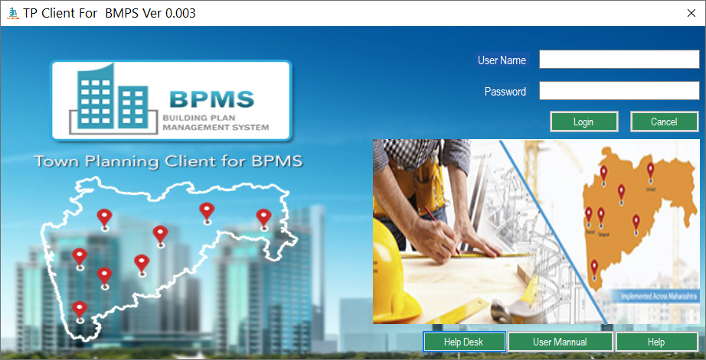

Fig.TP-Client Offline Software

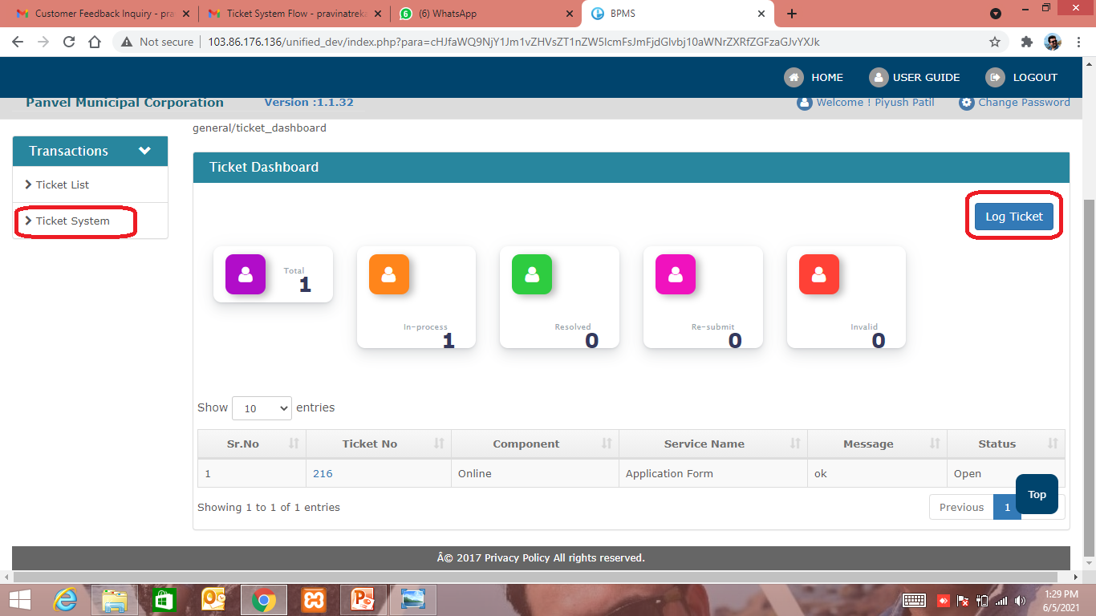

Fig. Ticket System Dashboard

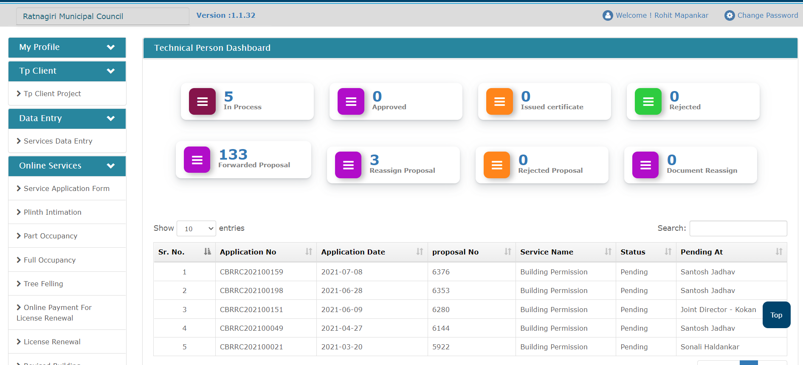

Fig. Applicant Profile

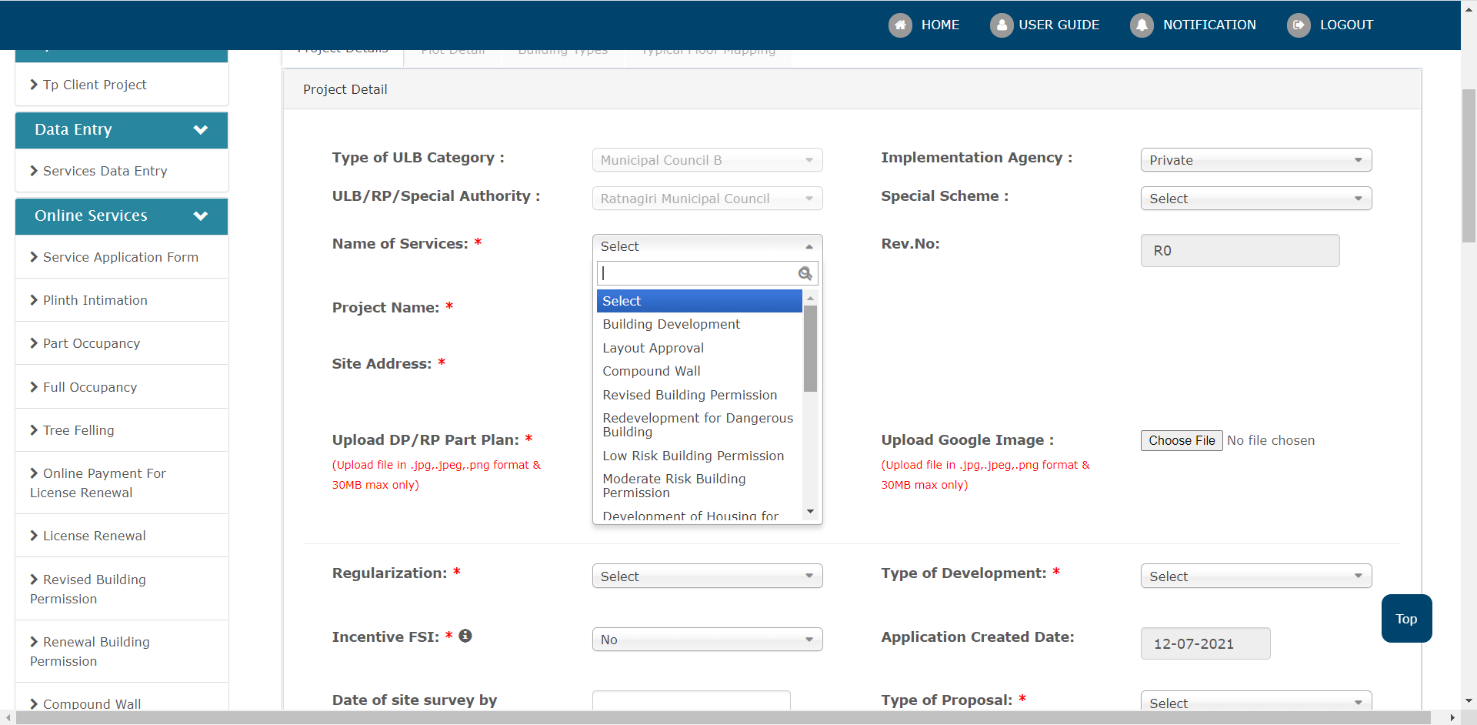

Fig. Application for the Services

**5.3. RESULT ANALYSIS**

The results are analyzed on the basis of SQL queries and reports such as

* Proposal Approved
* Region Wise
* Services
* Issue Logged and resolved as per Ticket System

It automatically helps the end users to register for building permission easily all the government process in done online using this portal.

**TESTING AND VALIDATION**

**6.1. INTRODUCTION**

**Software Testing Life Cycle (STLC)** is a sequence of different activities performed during the software testing process.

**Characteristics of STLC:** STLC is a fundamental part of [Software Development Life Cycle (SDLC)](https://practice.geeksforgeeks.org/problems/software-development-life-cycle) but STLC consists of only the testing phases.

STLC starts as soon as requirements are defined or software requirement document is shared by stakeholders.

STLC yields a step-by-step process to ensure quality software.

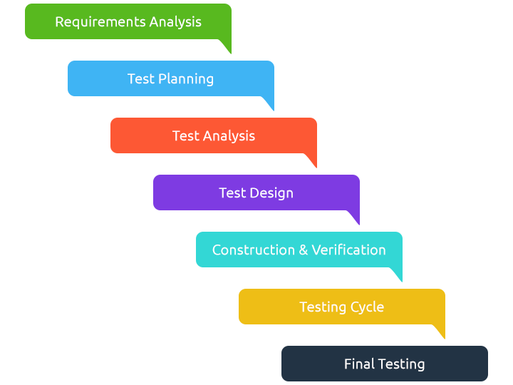

Fig. Software Testing Life Cycle

**6.2 TEST CASES AND REPORT**

* **Types of Testing**

**1)Manual Testing** is a type of Software Testing where Testers manually execute test cases without using any automation tools. Manual Testing is the most primitive of all testing types and helps find bugs in the software system.

Any new application must be manually tested before its testing can be automated. Manual Testing requires more effort but is necessary to check automation feasibility.

Manual Testing does not require knowledge of any testing tool.

**2)** **Automation Testing**means using an automation tool to execute your test case suite. On the contrary, [Manual Testing](https://www.guru99.com/manual-testing.html) is performed by a human sitting in front of a computer carefully executing the test steps.

The automation software can also enter test data into the System Under Test, compare expected and actual results and generate detailed test reports. Test Automation demands considerable investments of money and resources.

Successive development cycles will require execution of same test suite repeatedly. Using a test automation tool, it’s possible to record this test suite and re-play it as required. Once the test suite is automated, no human intervention is required. This improved ROI of Test Automation. The goal of Automation is to reduce the number of test cases to be run manually and not to eliminate Manual Testing altogether.

* **Types of Automation Testing**

**i) Unit Testing**

Unit Testing is a level of software testing where individual units/ components of a software are tested. The purpose is to validate that each unit of the software performs as designed. A unit is the smallest testable part of any software. It usually has one or a few inputs and usually a single output. In procedural programming, a unit may be an individual program, function, procedure, etc. In object-oriented programming, the smallest unit is a method, which may belong to a base/ super class, abstract class or derived/ child class. (Some treat a module of an application as a unit. This is to be discouraged as there will probably be many individual units within that module.) Unit testing frameworks, drivers, stubs, and mock/ fake objects are used to assist in unit testing.

**ii)** **Smoke Testing**

Smoke Testing, also known as “Build Verification Testing”, is a type of software testing that comprises of a non-exhaustive set of tests that aim at ensuring that the most important functions work. The result of this testing is used to decide if a build is stable enough to proceed with further testing.

The term ‘smoke testing’, it is said, came to software testing from a similar type of hardware testing, in which the device passed the test if it did not catch fire (or smoked) the first time it was turned on.

**iii)Functional Testing**

In functional testing basically the testing of the functions of component or system is done. It refers to activities that verify a specific action or function of the code. Functional test tends to answer the questions like “can the user do this” or “does this particular feature work”. This is typically described in a requirements specification or in a functional specification. The techniques used for functional testing are often specification-based.

Testing functionality can be done from two perspectives:

i) Requirement-based testing: In this type of testing the requirements are prioritized depending on the risk criteria and accordingly the tests are prioritized. This will ensure that the most important and most critical tests are included in the testing effort.

ii) Business-process-based testing: In this type of testing the scenarios involved in the day-to-day business use of the system are described. It uses the knowledge of the business processes.

**iv) Integration Testing**

Integration Testing is a level of software testing where individual units are combined and tested as a group. The purpose of this level of testing is to expose faults in the interaction between integrated units. Test drivers and test stubs are used to assist in Integration Testing.

**V)Regression testing**

Regression testing is defined as a type of software testing to confirm that a recent program or code change has not adversely affected existing features. Regression testing is nothing but full or partial selection of already executed test cases which are re-executed to ensure existing functionalities work fine. This testing is done to make sure that new code changes should not have side effects on the existing functionalities.

Regression Testing is required when there is a

* Change in requirements and code is modified according to the requirement
* New feature is added to the software
* Defect fixing
* Performance issue fix

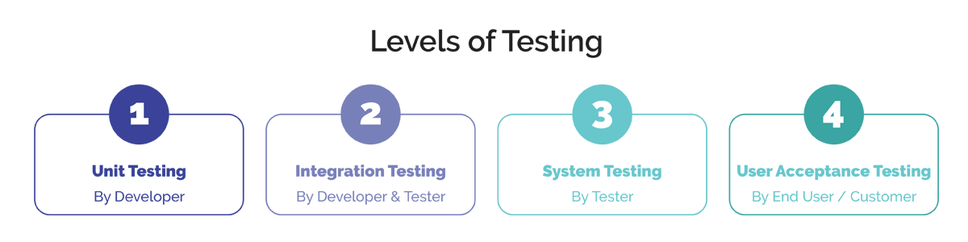

Fig. Levels of Testing

**FUTURE ENHANCEMENT**

1. We are trying to create mobile application.
2. We are even planning to make add more facilities and make it better for using it.

**LIMITATIONS**

It gives error while updating the few details.

**CONCLUSION**

It was a wonderful and learning experience for me while working on this project. This project took me through the various phases of testing life cycle and gave me real insight into the world of software testing. The joy of working and the thrill involved while tackling the various problems and challenges gave me a feel of testers industry. It was due to this project I came to know how professional software testing is done. I enjoyed each and every bit of work I had put into this project. The project is further extendable.

**REFERENCES**

1. Author: Vaswani

Book: “The Complete Reference”

Publisher: McGraw Hill

Year of Publication: January 2014

1. Author: Balaguruswamy

Book: “Programming with JAVA - A Primer: Third Edition”

Publisher: McGraw Hill-Education

Year of Publication: 4 June 2014

1. S2 InfoTech International Limited Website: <https://www.s2iil.com/about.html>
2. BPMS Website: <http://mahavastu.maharashtra.gov.in/index.php>